CSA1503-CLOUD COMPUTING AND BIG DATA ANALYTICS
Experiment-15

Create a Snapshot of a VM and Test it by loading the Previous Version/Cloned VM
AIM
To create a snapshot of a Virtual Machine using VMware Workstation and restore the virtual machine to the previous saved state using the snapshot feature.

PROCEDURE
Part A: Creating a Snapshot
Step 1: Open VMware Workstation.
Step 2: Select the Virtual Machine (e.g., Ubuntu).
Step 3: Power on the Virtual Machine.
Step 4: After the operating system loads completely, click VM from the menu bar.
Step 5: Select Snapshot → Take Snapshot.
Step 6: Enter a Snapshot Name (e.g., Snapshot1) and an optional description.
Step 7: Click Take Snapshot.
The snapshot is now created successfully.
Part B: Testing the Snapshot
Step 8: Make some changes inside the Virtual Machine (for example, create a folder named TestFolder on the desktop).
Step 9: Shut down or keep the VM running.
Step 10: Click VM → Snapshot → Snapshot Manager.
Step 11: Select the snapshot (Snapshot1) from the list.
Step 12: Click Go To (Restore).
Step 13: Confirm the restore operation.
Step 14: Verify that the Virtual Machine has returned to the previous state (for example, the TestFolder created after the snapshot no longer exists).
IMPLEMENTATION
STEP 1: Select the Create a new virtual machine
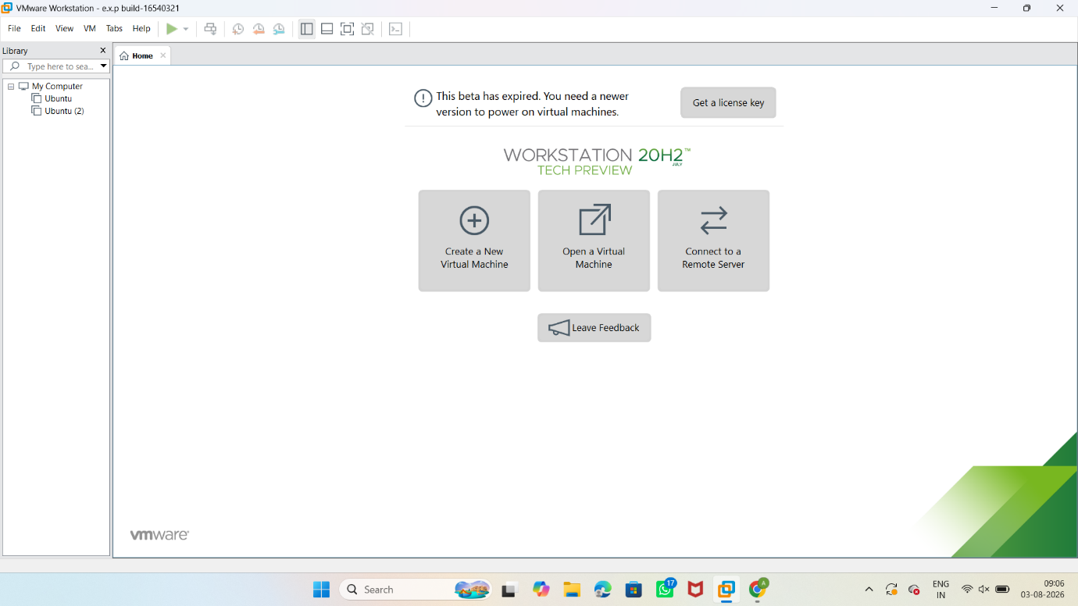

STEP 2: click VM from the menu bar.
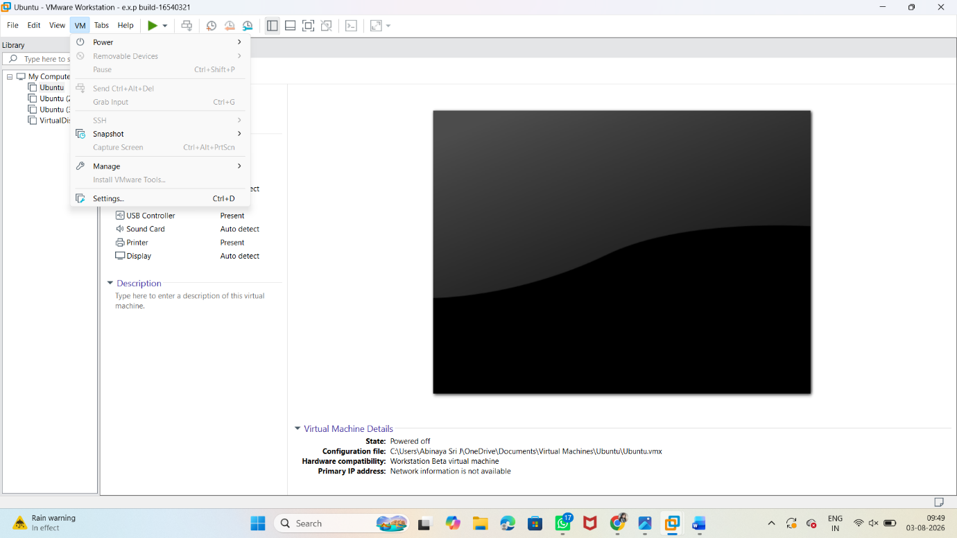

Step 3: Select Snapshot → Take Snapshot.
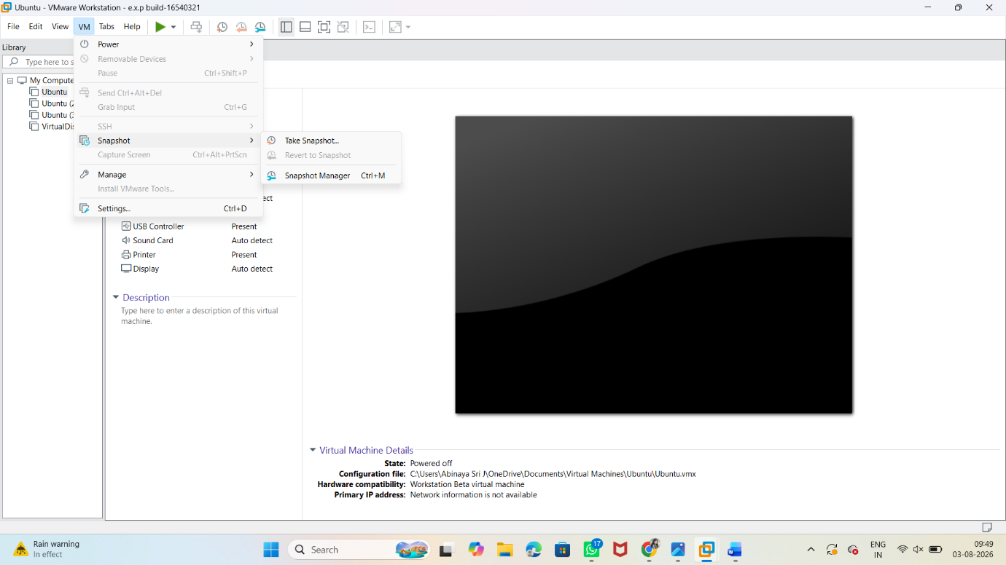

STEP 4: Enter a Snapshot Name
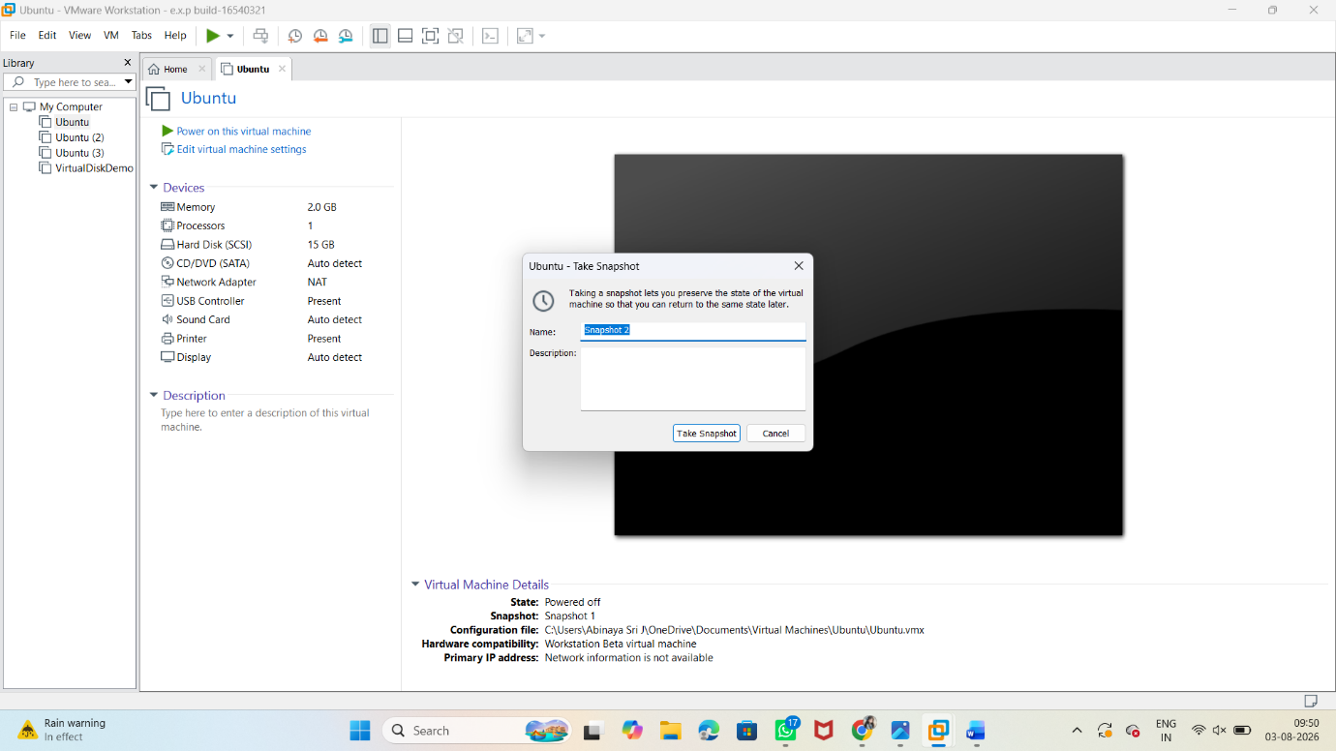

OUTPUT
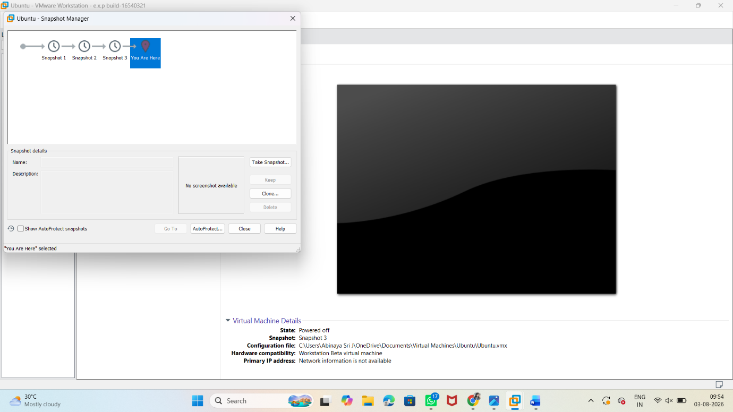

Part B: Testing the Snapshot

Click VM → Snapshot → Snapshot Manager.
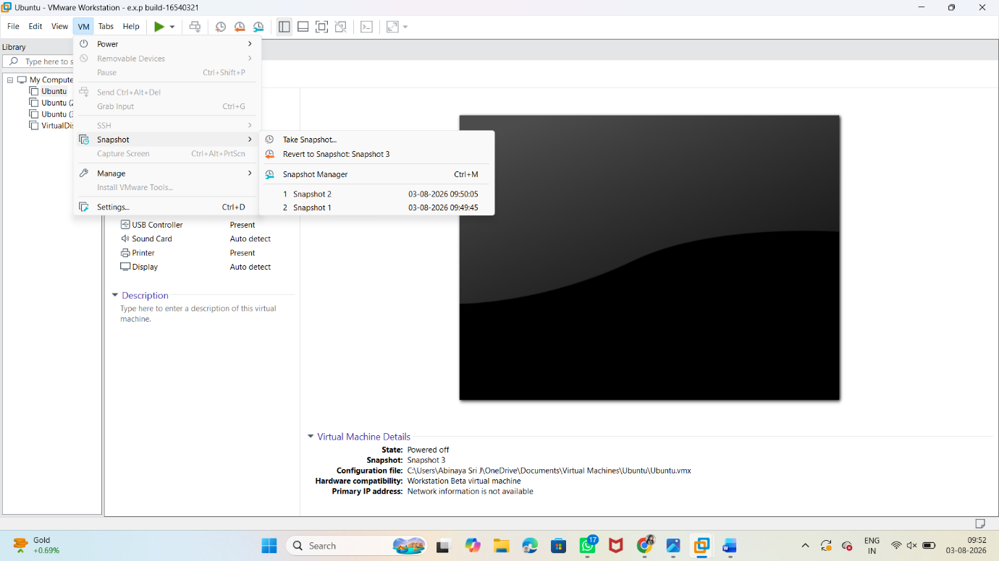



Select the snapshot (Snapshot2) from the list.
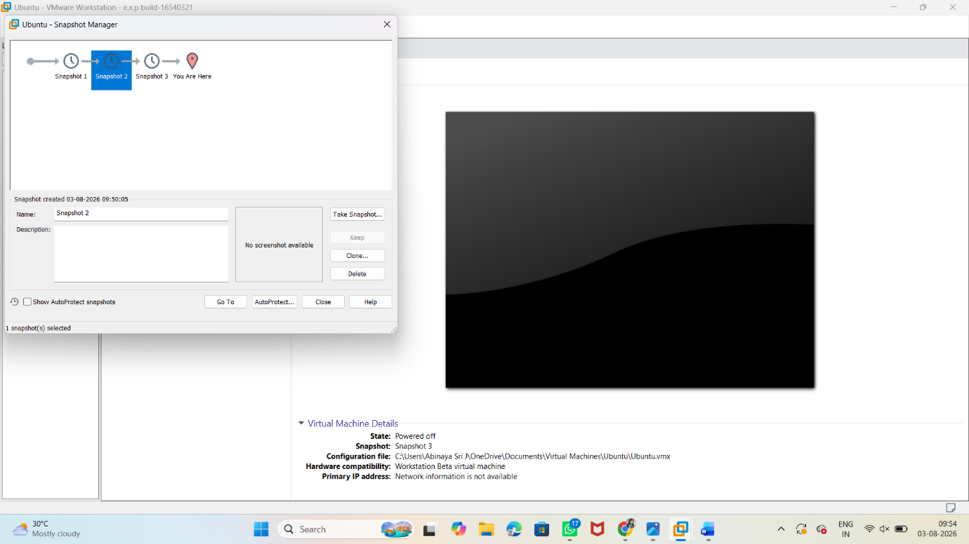

Click Go To (Restore). Verify that the Virtual Machine has returned to the previous state
